|  |  |  |  |  |
| --- | --- | --- | --- | --- |
| Please indicate selected lunches on both charts.  **Top Form and Bottom Form** | Please return order form and payment to the office by **Monday, May 21 , 2018.** | **ST. MARIA GORETTI SCHOOL**  **STUDENT LUNCH ORDER FORM**  **June, 2018** | Each order includes: One drink (Juice, Chocolate Milk, Water or Milk)  Fruit (one choice of seasonal fruit).  Salad (with balsamic, Italian, or home made ranch dressing, and croutons)  Student Name______________________Grade________ | |
| **Monday** | **Tuesday** | **Wednesday** | **Thursday Friday** | |
| SMGS |  |  |  | **1**  Noon Dismissal  **No Lunch** |
| **4**  1. Chicken Nuggets  2. Pizza Rolls  *(Served w/ Mush Potatoes)* | **5**  1. Cheeseburger  2. Hamburger  3. Chicken Patty Sandwich  *(Served w/ Fries )* | **6**  1. Chicken Teriyaki  2. Taquitos  (*Served w/* *Steamed Rice)* | **7**  1. Chicken Tenders  2. Mini Corn Dogs  (*Served w/* Maccaroni And Cheese*)* | **8**  1. Cheese Pizza  2. Pepperoni Pizza  3. Sausage Pizza |
| **11**  1. Hot Dog  2. Chili Dog  3. Baked Chicken | **12**  1. Cheese Pizza  2. Pepperoni Pizza  3. Sausage Pizza | **13**  **10 am. Dismissal**  **No Lunch** | **14**  [This Photo](http://en.wikipedia.org/wiki/File:Culinary_fruits_top_view.jpg) by Unknown Author is licensed under [CC BY-SA](https://creativecommons.org/licenses/by-sa/3.0/) | **15** |
| **18** | **19**  [This Photo](http://douglassalumni.blogspot.com/2014/07/douglass-alumni-fundraiser-somethings.html) by Unknown Author is licensed under [CC BY-ND](https://creativecommons.org/licenses/by-nd/3.0/) | **20**  [This Photo](http://www.theidearoom.net/2014/05/graduation-gift-pinterest-party.html) by Unknown Author is licensed under [CC BY-NC-ND](https://creativecommons.org/licenses/by-nc-nd/4.0/) | **21** | **22** |
| **25** | **26** | **27** | 28 29 | |

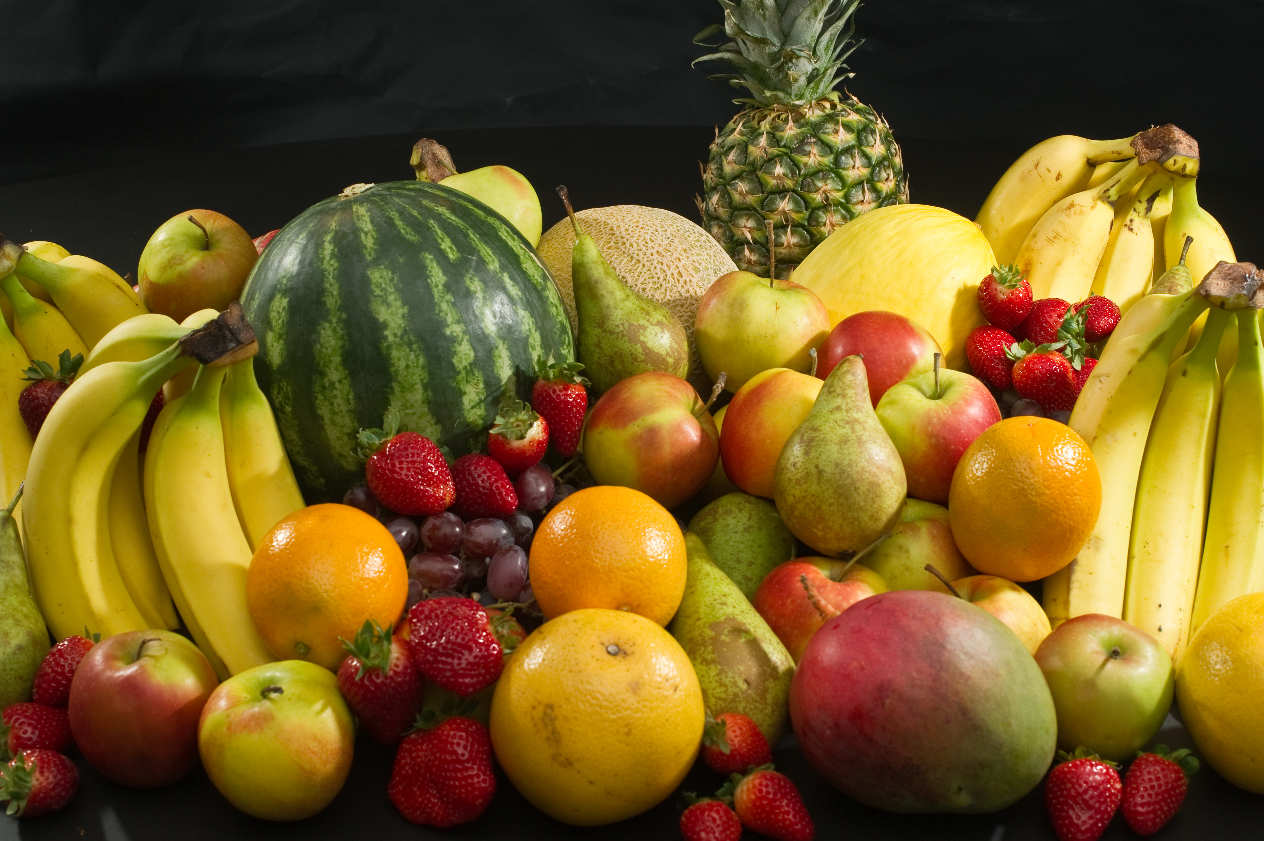

|  |  |  |  |  |
| --- | --- | --- | --- | --- |
| **Monday** | **Tuesday** | **Wednesday** | **Thursday** | **Friday**  June, 2018  (maximum 7) = 7=_________x$4.50=$___________  Pre-order lunch is convenient. You can save money and time. Thank you.  For issues, questions or concerns:  Please contact: [gabrielrivas4@aol.com](mailto:gabrielrivas4@aol.com) (626-549-7906)  Please provide your Telephone # _____________________  E-Mail: _________________________________________  ***Please Make Check Payable to Happy Lunch.*** |
| May 2018 |  |  |  | **1 Noon Dismissal** |
| **4**  **1 2 3** | **5**  **1 2 3** | **6**  **1 2 3** | **7**  **1 2 3** | **8**  **1 2 3** |
| **11**  **1 2 3** | **12**  **1 2 3** | **13**  **10 am. Dismissal** | **14**  [This Photo](http://en.wikipedia.org/wiki/File:Culinary_fruits_top_view.jpg) by Unknown Author is licensed under [CC BY-SA](https://creativecommons.org/licenses/by-sa/3.0/) | **15** |
| **18** | **19**  [This Photo](http://douglassalumni.blogspot.com/2014/07/douglass-alumni-fundraiser-somethings.html) by Unknown Author is licensed under [CC BY-ND](https://creativecommons.org/licenses/by-nd/3.0/) | **20**  [This Photo](http://www.theidearoom.net/2014/05/graduation-gift-pinterest-party.html) by Unknown Author is licensed under [CC BY-NC-ND](https://creativecommons.org/licenses/by-nc-nd/4.0/) | **21** | **22** |
| **25** | **26** | **27** | **28** | **29**  **SMGS** |

**Student Name________________________Grade________**